Mechanics of breathing,
Pleural space is the space between rib cage and the lungs, it is filled with small amount of fluid.
Pleural space
- Function: couple the chest to the lungs. When breath in, bring down the respiratory muscle to contract. Chest size will enlarge, and the diaphragm will go down, the intercostal contract. The lung will be pull open due to the coupling between chest and lungs by pleural space.
- Right and left pleural space are separated (don’t connect to each other)
- When breath:
- Pull on the rib cage
- Decrease the pressure inside the pleural space(which is already negative )
Pleural space is negative, due to the lung always want to collapse but the rib cage tend to expand.
At rest, the pressure in the pleural space, the pleural pressure (Ppl), is negative. This is due to the opposing forces acting on the lung and chest wall. Indeed, if a hole is punctured through the chest wall (pneumothorax), the lungs collapse and the chest springs outwards.
- The pressure outside 0. Before taking the breath , nose and mouth are open therefore the pressure inside and outside are the same (all 0) There is no air flow. The pleural pressure is negative, due to the opposite force of lung and chest (but lung wants to collapse more.) Think about two slides with H2O inside, can’t be pull apart. If keep on pulling the glass, the pressure in between is negative ( due to the fluid inside is not expand or compressible) this pleural space couple the lung and the chest so that when contraction the chest muscle will open the lungs.
- The way we breath is by generating negative pressure.
- In pneumothorax : a hole is punched to the rib cage. The lung become smaller (lung is like a balloon, and now there isn’t anything to pull on it ) due to the coupling is removed. The air goes inside the rib cage -> no more coupling -> lung collapse. The rib cage expands.
** How easy/difficult it is to inflate the lung.
- In some disease: lung can be really easy or difficult to inflate/deflate
- Think of a balloon: 1 is really easy to inflate the other is really hard to inflate
- How do you know that? You took a balloon, and apply pressure to see the volume change. => (small vs large volume)
- To describe the easy/difficult to inflate the lung: relate to the pressure applied to the volume that it gets. (Pressure +volume)
Elastic properties of the lungs and chest wall
Here, we talk about the static property which is the pressure related to volume inflate. => describe the elastic.
- To evaluate the elastic properties of the respiratory system (chest wall and lungs), we measure changes in the recoil pressure of each separate structure for a given change in lung volume.
- The pressure inside the balloon is he recoil pressure (balloon always want to recoil.)
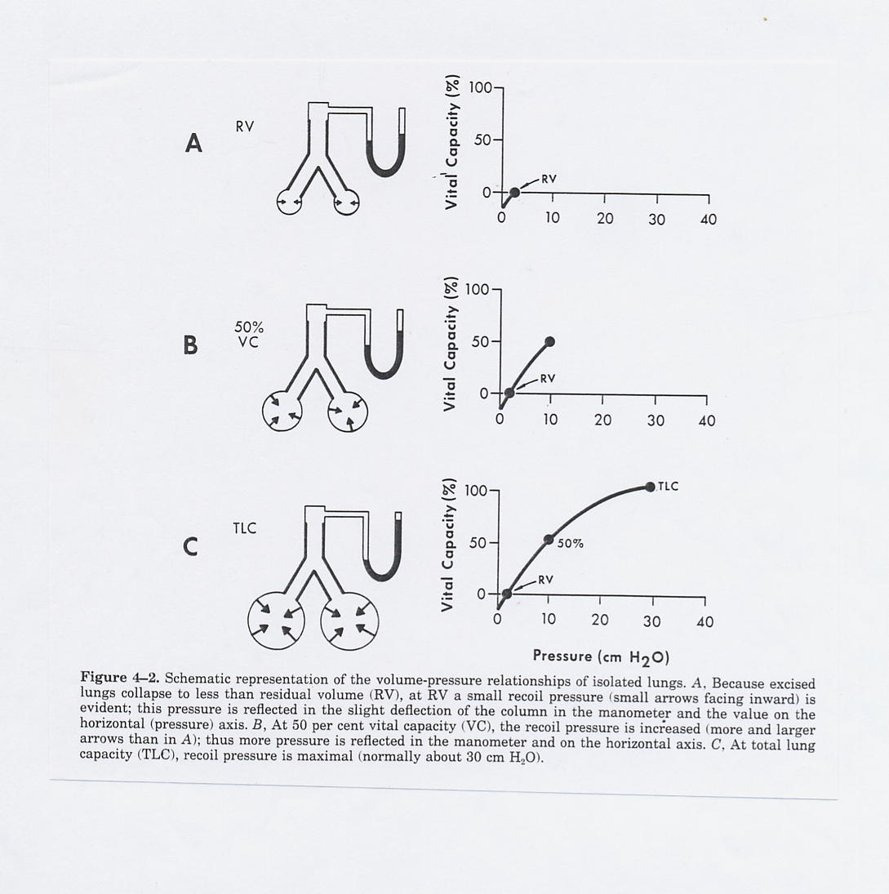
- Lung volumes can be measured by spirometry.
- This is a manometer
- A lung here is attach to manometer which is a tube with water, mercury or any measurement.
- When apply pressure into the lung to inflate the lungs.
- The manometer will be deflected, the water will moved up. (push the column): this allow you to quantify the pressure by centimetre of water.
- Pressures are measured using manometers or pressure transducers, referenced to atmospheric pressure.
- "Negative pressure" indicates a pressure below atmospheric, and "positive pressure" indicates a pressure above atmospheric pressure. (we refer 0 as atmospheric pressure)
- Recoil pressure(think of the pressure it want to collapse) : pressure difference between the inside and outside (transmural pressure).
- Think: decrease the pressure around the balloon, the balloon will inflate (like the lung.) The volume inside refer to outside: transmural pressure, transpulmanary pressure.
- -the pressure outside the lung: pleural space. (this is negative)
- How to measure the pleural space pressure?
- Esophagus is very similar to pleural pressure
- Trick: Measure the pressure inside the esophagus: this is the pleural space pressure
- This is done by having a pressure transducer which is connect to a catheter, there is a balloon in the end, and you swallow the balloon and allow it to pass through the nose. This is call esophageal catheter (esophageal balloon), give you Ppl.
- Because the esophagus is located between the two pleural spaces, esophageal pressure provides a close approximation of Ppl.
- Ppl can be measured using a flexible balloon introduced into the esophagus.
- The body surface (bs) is under atmospheric pressure.

Note that in this static example, Pao= Pbs = Patm

- The gray region is just showing there is tons of alveoli.
- The white part in between is pleural space, and the back outside is the rib cage.
- The transpulmonary pressure ( PI) : difference between alveoli and the pleural space.
C. Compliance
Compliance shows how easy or difficult it is to inflate the lungs
Compliance of the lungs:
- Compliance of the lungs, or chest wall, or total respiratory system, is a parameter that refers to the ease with which each of these structures can be distended. ( like the balloon)
C = ΔV / ΔP (memorize) – the change in volume in an given change in pressure
Ps. There is 2 equations you need to memorize in this class

- The standard procedure for measuring the respiratory system compliance in humans is to determine the static pressure-volume relationship while lung volume is decreased step by step from TLC.
ask the subject to increase the lung volume and measure the corresponding pressure change, and you can build the curve that shows: Static pressure-volume curve
- Lung is hook up with spirometer.
- We start from the bottom picture ©
- Inflate the lung to total capacity, and measure the pressure difference => record on the 100% in the right curve.
- Deflate the lung to 50%, and record the manometer pressure on the right.
- Deflate the lung to residual volume, record
- This give us the Pv curve, this tell us it is harder and harder to inflate the lung at the bigger volume. 10 cm H2O pressure change in 0% and 50% is different. => harder and harder to stretch the tissue.
- Compliance is the slope of the curve, C = ΔV / ΔP (difference In volume/ difference in pressure) .At the top, the slope is flat, this means the compliance is less
- Less compliance at high lung volume than at low lung volume.
This equation is more complex than previous:
Why?
- C= V/P is the lung outside the air (no need to worry about difference in pressure of pleural space. The pressure in pleural space is outside) think: your lung is in the air
- In reality, you have to account the difference in pressure between inside the lung and outside the lung (outside the lung is the pleural pressure ) => Cl = ΔV / (ΔPalv - ΔPpl)
- So here: you measure the pleural pressure in real subject than subtract the pleural pressure from alveolar pressure to tell the pressure difference
- To measure the alveolar pressure>
Subject breath in the given volume, and close the nose and mouth, hold breath. You then put a catheter in the mouth. => The pressure in the mouth is the same as lungs (alveoli) this tells : Palv.
Esophageal pleasure: Ppl.
- Compliance is expressed as the volume change in the lungs for a unitary change in pressure, i.e. the slope of the pressure-volume curve.
Cl = ΔV / (ΔPalv - ΔPpl)
- The pressure required to maintain a given volume of gas inside the lungs increases as the volume increases, i.e. the slope decreases with increases in lung volume.
- Compliance of the lungs is also altered in diseases such emphysema and fibrosis.
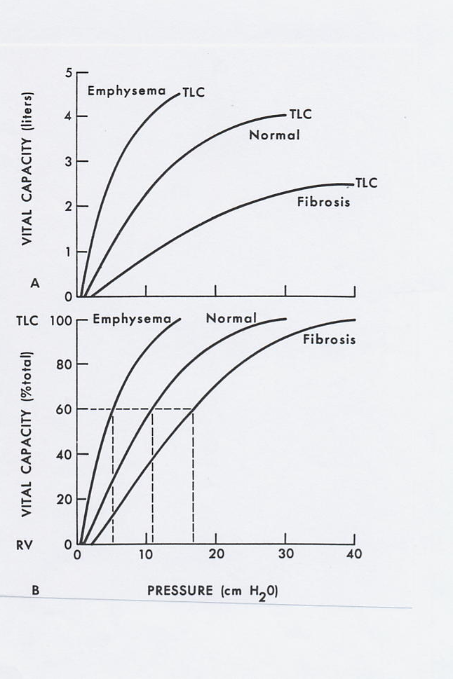
In diseases, the top graph:
In fibrosis: stiffing of alveolar tissues. The lungs are stiff.
- The Pv curve:
-The fibrosis patient have less volume than normal due to the stiff lungs (hard to inflate)
- Emphysema : breakage in alveolar wall, alveoli is very floppy and easy to inflate, they have a larger volume capacity. Emphysema patient have no problem in breath in but problem to breath out. ( too floppy to breath out)

Compliance vs Elastance
- Elastance= 1/compliance
Elderly subject who have problem in breading, they have a stiffer rib cage.( problem in bones)
- We need to describe how difficult it is to move the rib cage.
- The compliance of the rib cage
Compliance of the chest wall
The tissues of the chest wall also have elastic properties that cause it to recoil either inward or outward, depending on its volume.
- The difference between the pleural space and outside (P outside = 0)
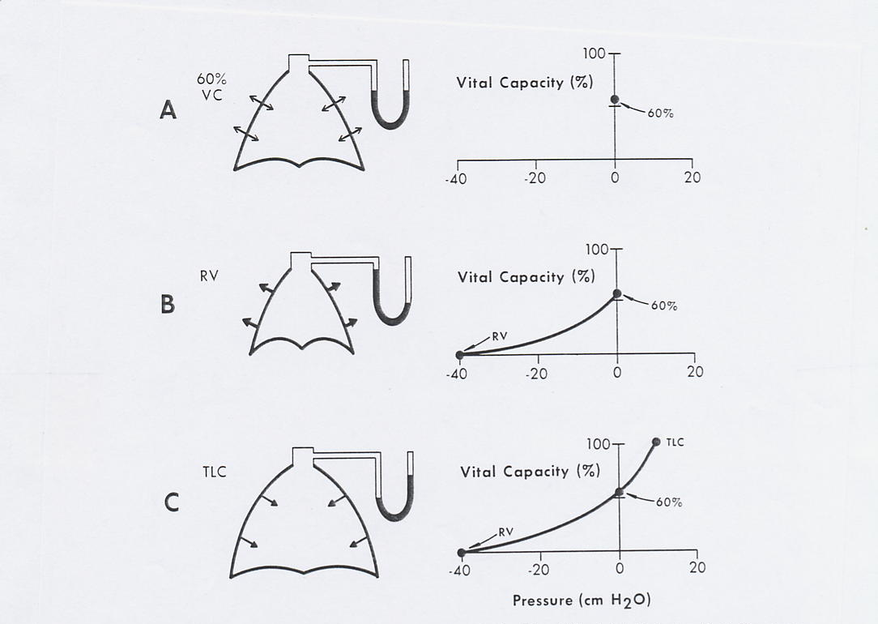
- Hook the rib cage to manometer.
- X axis : pressure
- Y axis: Vital Capacity
If the Rib cage is 60% vital capacity (vital capacity =the volume of lung): there is no pressure generated: 0. => This is the pressure where rib age is under equilibrium. (No pressure generation)
In pic C, at total lung capacity, generate a positive pressure. The chest here wants to recoil (look at the arrows,) so it is generating a positive pressure. (like the lungs, when the lungs tend to collapse it will generate a positive pressure). Once the chest is over 60% vital capacity, it wants to recoil and generate the positive pressure.
The rib cage now in residual volume (picB), the rib cage wants to expand. This is generating a negative pressure.
This is our Pv curve for rib cage. Unlike the lung which always tend to collapse,The rib cage is a solid structure. Sometimes it tend to collapse, and sometimes it want to expand.
Compliance of the chest wall
The compliance of the chest wall is defined in terms of a change in thoracic volume ΔV (the change in volume of the thorax is the same as the change in volume of the lungs) and a change in pressure across the chest wall, ΔPpl.
Thus,
Cw = ΔV / ΔPpl ( The pressure here; Is the difference between pressure inside(pleural space) and the outside (but the outside =0, it is air) so it is Ppl.)
Pressure of the whole system
Prs (Pressure across the respiratory system) is the difference between alveolar pressure and the outside pleasure.
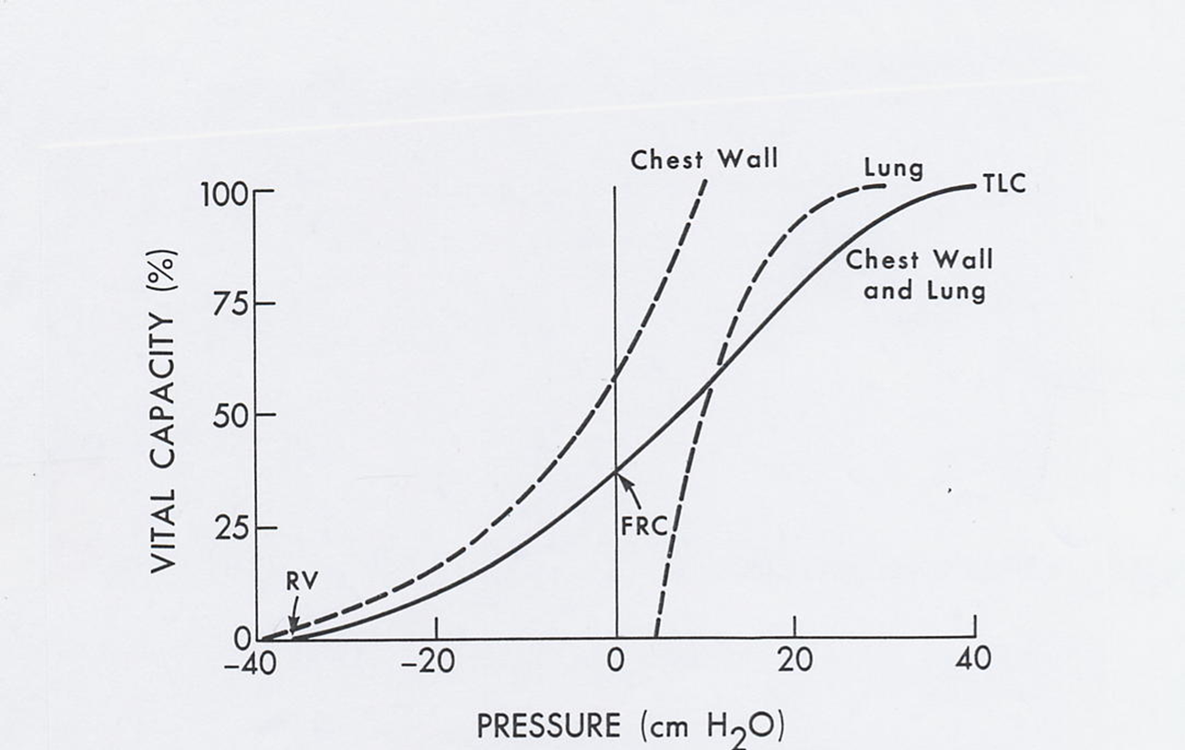
Volume-pressure relationships of chest wall and lung combined (solide line).
Total lung capacity: need to add up the pressure to bring the chest to that volume and the pressure to bring the lung to that volume. ( So: P chest + P lung =PTLC) The Tlc curve can be done by adding up.
-At 60% vital capacity: in chest wall, no need to generate pressure (equilibrium), but need to generate pressure to the lung.
- At FRC, to inflate the lung to 60%vital capacity is equal in opposite (comparing lung and chest wall) –see the red line. So, The pressure at this volume for the lung to deflate = the pressure of the chest to spring out. This is the functional residual volume. ( Remember in the first lecture , we said when we breath out, we breath out to functional residual capacity because this is the equilibrium of respiratory system => the lung collapse pressure = the chest wall want to expand) This is why this is FRC, the equilibrium.
FRC
At FRC, Prs (pressure across the whole respiratory system) is zero because the system is at rest. This stable condition is caused by the inward recoil of the lungs (Pl is about +5 cmH2O) which is balanced by the outward recoil of the chest wall (Pcw is about -5 cm H2O). This means that, at FRC, the lungs are above their resting volume (still want to collapse) and the chest is below its resting volume (recall the concept of the pneumothorax).
the pneumothorax : if you stop the coupling, both go to the resting volume . Lung low colume. Rib cage bigger volume.
Pneumothorax
The elastic properties of the respiratory system are best illustrated by what happens when the chest is opened during thoracic surgery, i.e. a pneumothorax. Air enters the pleural space because Ppl is less than atmospheric pressure. The lungs collapse to its resting position below RV, and the chest wall expands towards its resting position, at about 75% of total lung capacity. A traumatic or spontaneous pneumothorax may be a life-threatening emergency since the lungs are uncoupled from the chest wall. (The pleural spaces is separated, you don’t get pneumothorax on both side)
-another syndrome: In young child (usually man who grow fast): spontaneous pneumothorax, the lungs tissue by itself will break, air go to the pleural space from the inside.
- Can also happen due to infection.

